# **Executive Summary:**

The Covid-19 outbreak had impacted the daily routine of citizens globally and in many aspects. Consumption and demand for products had experienced a remarkable decrease due to lockdown measurements and the fear of contamination while shopping. Hence, the digital transformation was a global alternative solution to face the sanitary crisis.

In this study, we examined the online purchasing behavior during the pandemic in Tunisia.

We studied the effect of Covid-19 on the online purchasing behavior, the buyers’ satisfaction with the online purchasing experience, and their perception of the readiness of local businesses regarding the online shift. Besides, we tried to get an idea about the continuity of the behavior of Tunisians after the pandemic and the factors influencing it.

Throughout the analysis, we discovered that the pandemic outbreak affected the frequency of online purchasing in Tunisia; respondents were satisfied with the online purchasing experience, they think that local businesses succeeded in the online shift, and they are willing to shop online sometimes when the pandemic is over. We further estimated the factors influencing the continuity of the online shopping behavior after the pandemic and quantified their effect.

Our recommendations would be encouraging local businesses to shift online if they did not already, especially if they are working on fast-food, fashion, or personal care products. We also suggest that businesses enhance the user experience for online platforms and build customer loyalty programs to retain satisfied customers and ensure the continuity of their behavior.

# **Study Context**

## **General introduction**

The projected increase in the compound annual growth rate of the global digital transformation market size is expected to be 16.5% going from USD 469.8 billion in 2020 to USD 1009.8 billion by 2025; this market is empowered by the penetration of IoT and cloud services. One major reason that has considerably accelerated the growth of digitalization is the Covid-19 pandemic during the year 2020. The e-commerce sector has seen significant uplift during this pandemic and incited businesses to make the switch and seek digital transformation. In this context, according to the “*B2B”* Consulting Firm, online commerce in Tunisia is a sector that is prospering and will continue to prosper after the Coronavirus crisis, this was mainly demonstrated through the expansion of online sales in Tunisia especially for *Jumia* who was one of the top 3 players during the pandemic. Major factors, such as the global lockdown, the curfew, the risk of contamination through waiting in closed areas, and contacting people, created a need for online services. Thus, e-commerce has gradually become a real alternative to physical commerce and a field of activity. These new business aspects and consumer behavior changes are being investigated worldwide to examine how the Covid-19 pandemic affected the online markets by causing fluctuations in demand driven by the consumers, which will be the objective of this study.

1. **The Industry**

According to Glopal for Merchants: *Tayara.tn, jumia.com.tn and tunisie-annonce.com* are considered the top e-commerce sites in Tunisia (Glopal for merchants, s.d.). *Tayara*, created in 2012, is a website dedicated to selling and buying goods online. Like its French equivalent, Le Bon Coin, it is generating profit through its system which is based on advertising and the visibility of ads. *Tayara* has an average of 3.51 million visits per month. During August 2020, it has reached the highest number of visits which is 4.05 million over six months. *Tunisie annonce* is also offering the same services and products as *Tayara.tn.* *Jumia* launched its office in Tunisia, in 2014. It has three main events which are Mobile Week, *Jumia*’s birthday, and Black Friday. *Jumia* offers a wide range of products such as electronics, Makeup, clothes, etc. Moreover, it offers a delivery service which is called Jumia Food. In 2017, *Jumia* has recorded 1 million visits and 13,000 orders per month. *Founa.com*, founded by Karim Skik in 2013, is a retail eCommerce website. *Founa* had two categories of customers: members of the Founa club and other customers. Members of the Founa club are the loyal customers who buy regularly from Founa, and they were able to pay on delivery using cash or checks. In 2018, Magasin Général (Mg) bought 80% of Founa’s capital. A new player has recently entered the industry. *IntiGo* has also tailored an eCommerce site called “intishop” to respond to its customers' needs. It is offering multiple products such as food, groceries, and electronics. *IntiGo* was founded in late 2019 by Bassem Bougerra and Nebil Jridet, and they launched their new service “intishop”, during the first lockdown in Tunisia.

## **The market**

The number of internet users represents 55.07% of the whole Tunisian population. According to DataReportal’s report “Digital 2020”, the number of internet users has reached 7.55 million in January 2020 (Data reportal, 2020). According to the survey done by MDWEB, the national institute of consumption and SEVAD in 2018, 58% of respondents bought at least one item online through Tunisian websites during the last 12 months. As the rate of internet penetration increased significantly between 2018 and 2020, the number of Tunisian users who made at least one purchase online is expected to also increase.

## **The environmental context of the problem**

• Past Information and Forecasts

In October 2018, MDWEB, the national institute of consumption, and SEVAD conducted a study on 1064 Tunisian consumers from different regions of the country (MDWEB, 2018). The survey was posted online via social media.

The sample included people aged 18 and above, 70% of whom are men. 56% of the respondents live in Grand Tunis. Moreover, 40% of the sample are graduates “Bac + 5” and 35% are working in higher management positions “Cadres Supérieurs”.

The study has revealed that 58% of the sample have purchased online during the previous twelve months, 65% have purchased online via websites and social media, and 78% have purchased online at least once. Moreover, during the previous month, 74% of the respondents have purchased online via websites and 31% of the surveyed people have purchased online via social media (Facebook, Instagram, etc.)

The most purchased products and services are flight tickets (54%), paying bills (54%), sports and toys (49%), and clothes (47%)

The most purchased products and services are flight tickets (54%), paying bills (54%), sports and toys (49%), and clothes (47%)

To finalize the transaction, 78% of the sample used their PC, 66% used their mobile, and 15% used their Tablet. Furthermore, 66% of the surveyed people used their bank cards to pay for the items, 56% used cash on delivery and 20% used their E-dinar card.

Within the sample, 67% of the online buyers are overall satisfied because of lower prices, time-saving options, and their ability to compare products. On the other hand, 25% of the surveyed people are dissatisfied because of the payment problems, delayed delivery, and bad service. To conclude, the research proved that 79% of the buyers intend to re-buy online and 79% of the non-buyers intend to buy online.

• Resources and Constraints

A team of five students has worked on this study. Firstly, the time available has not allowed us to conduct an in-depth study. Unlike MDWEB’s report, we had a short period of time to reach respondents. Due to COVID-19 and our geographical locations, most of our meetings were online.

Time allocated to collect responses: from the 30th of November to the 15th of December.

The budget allocated to the research: 0 TND

• Objectives

Our study will be a support for businesses to understand and adapt their business models through the conclusions that will be drawn after the analysis and investigation of the online market behavior in Tunisia during the Covid-19.

• Buyer behavior

In general, when making purchases, Tunisian customers have become more demanding: they are looking for substantive details on the goods they are interested in buying, their availability, and the brand they are under. Word-of-mouth from their relatives considerably influences their decision to buy. According to a study published on the Marketeuz website, Tunisians would prefer to go out to buy the products because of their extroverted and communicative personalities (MarketeuZ, 2008). For specific motives rather than the act of buying, they like to go to a point of sale and attempt to negotiate rates and have direct contact with the seller.

• Economic environment

The economic performance remained low for the year 2020, following the impact of the pandemic on the Tunisian economy. Trade indicators for merchandise in many vital sectors such as energy and mining were stagnating due to the exports and the breakdown of the import. Moreover, the tourism and hospitality sector has suffered from the Coronavirus impact and its revenues drastically dropped, affecting the economy as it is one of the pillars affecting the growth of the country’s economy. It is forecasted that the economy would recover in 2021, yet a lot of skepticism reigns over the matter as the COVID-19 duration is still unknown, however, the GDP is expected to grow by 4% in 2021 and by 4.1% in 2022.

# **Research problem, objectives, and approach to the problem**

1. **Research problem:**

Examine the effects of COVID 19 on the online purchasing behavior of consumers in Tunisia.

1. **Marketing Research Objectives:**

* Examining the effect of the COVID-19 pandemic on online demand
* Measuring the online business capabilities (adaptability to change.)
* Measuring user’s satisfaction with the online shopping experience
* Examining the potential of the current online behavior after the pandemic.

What needs to be investigated:

* Demographics: age, gender, internet access, income, educational level, online purchase, geographical location.
* Consumer sentiment: lifestyle change, demand (frequency).
* Identifying Service Output Demand gaps: satisfaction, payment, SODs importance.
* The readiness of local businesses: Customer perception of local business readiness to the digital shift based on the services they received (SODs).
* Consumer decision-making product categories, continuity of behavior after Covid-19.

1. **Approach to the problem:**

#### Analytical framework:

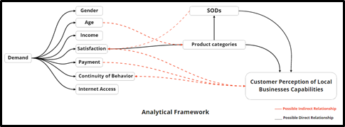

# **Research design**

### **Research design selection**

As already stated in the marketing research problem we are examining the online Tunisian consumer’s behavior through understanding the pattern of their purchasing behavior, their satisfaction in regard to the services provided, the products purchased, and how important the SODs are in determining their perception regarding the online market during the pandemic. In order to have clear conclusions, a conclusive research design is needed. So the study will rely on quantitative analysis, more specifically the descriptive research design.

### **Measurement and scaling:**

Since we are conducting descriptive research, we need to measure the characteristics related to the online purchasing behavior of Tunisians. Thus, we need to assign numbers to those characteristics in order to permit statistical analysis of the resulting data and facilitate the communication and presentation of those measurements. In our case, the scaling technique is more suitable to classify respondents according to their behavior based on predetermined characteristics (demand, demographic, SODs perception...). In fact, we used both comparative and non-comparative scales techniques. As for the comparative scaling, we used the order rank method to get insights about the ranking of the security of payment methods. The non-comparative techniques on the other hand were used to evaluate the perception of one characteristic at a time. We followed an itemized scaling technique. For instance, we used the Likert scale to measure the perception of respondents towards the capabilities of local businesses to shift online, we relied on a balanced, odd number of categories to be as objective as possible (5-point scales), and we labeled every scale category because the verbal description has the potential to improve the accuracy of the data and reduce ambiguity especially that the survey will be communicated online, and we cannot elaborate more about the scale to the respondent. After data collection, we run a reliability analysis for the SODs scales because they converge to the perception of the importance of SODs, and the attributes are interconnected. We found a Cronbach’s alpha of 0.652 >0.6. Therefore, our scale is considered reliable. Added to that, the KMO is equal to 0.75> 0.5 and our significance is zero, so our scale is valid and reliable.

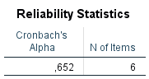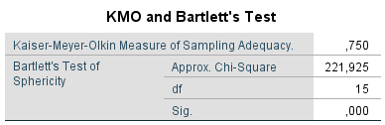

### **Sampling and sample design**

### **Population:**

The population to be studied is people who had online shopping experience(s) during the COVID-19 period.

### **Sample:**

Due to the lack of information by official Tunisian bodies about the number of people who shopped online during the COVID-19 period, we chose “internet usage” as an indicator of the population. To ensure the representativity of the sample, we added a filter question at the beginning of the survey to make sure that each element studied had a previous online shopping experience during the COVID-19 experience.

The sample recommended is 385 with a confidence interval of 95% and a margin of error of 5%. It is drawn from a population of 7.55 million internet users in Tunisia in 2020 (Data reportal, 2020).

The sampling method was intended to be simple random sampling, yet, due to time and resource constraints, we shifted towards quota sampling, with previous online shopping experience during the COVID-19 period as the main criterion.

### **Procedure of data collection**

We collected the secondary data from previous market research reports, official and public records, and public institutions reports such as the national statistics institute. As for the primary data, we designed an online questionnaire using Microsoft forms. We opted for Microsoft forms because it offers the ranking option. Firstly, we assessed the questionnaire by doing a pre-test. It was given to our friends and family members. We collected 21 responses with an average completion time of 5 minutes. Thanks to the feedback collected through the pre-test, we noticed that one region was missing “Gafsa”, a question was asked twice in the survey, and the French version did not notify the respondents whether their answers were submitted or not. The final version of the questionnaire was distributed via social media accounts of our team members because of the COVID-19 pandemic and the social distancing constraint. However, we found out that an online questionnaire serves the cause as we are targeting customers who bought at least once online, which means they are likely to have access to the internet. As a matter of fact, 7.3 million Tunisians have a Facebook account, which is equivalent to 96.68% of the number of internet users.

### **Procedure of data analysis**

We used SPSS version 20 as our data analysis tool. Once we had our dataset ready, we proceeded with the following steps:

Step1: data cleaning including questions labeling, variables coding, scales formatting, and checking for missing values.

Step 2: Univariate analysis to get a description and visualization of the variables independently.

Step 3: Bivariate analysis to explore the relationships between variables using different techniques such as cross-tabulation and principal component analysis, ANOVA, simple regression, multiple regression.

Step 4: Cluster analysis to extract potential clusters within our respondents’ group and describe the homogeneity *within* each cluster and heterogeneity *between* them.

# **Results: Data analysis and interpretation**

**1- Descriptive results and General profile of the respondents:**

**A- Univariate analysis**

* The general profile of the respondents

Gender

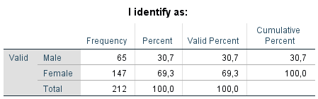

We noticed that 69.34% of our respondents were females.

Age

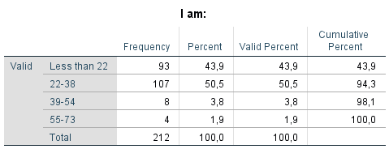

43.9% of respondents surveyed are less than 22 years old while 50.5% are aged between 22 and 38 years old. People aging between 39 and 54 years old represent 3.8% of the respondents and the remaining 1.9% are people aging between 55 and 73 years old.

Status

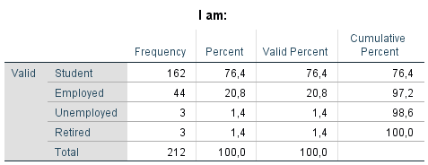

76.42% of the respondents surveyed are students and 20.75% are employed whereas retired and unemployed respondents were equally represented 1.42% each.

Income

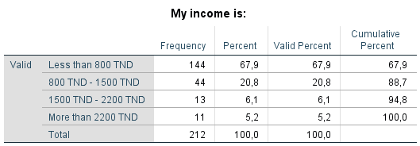

88.7% of our respondents’ incomes do not surpass 1500 TND. However, 6.13% among them have a monthly income between 1500 TND and 2200 TND, and only 5.19% are being paid more than 2200 TND per month.

Geographical region

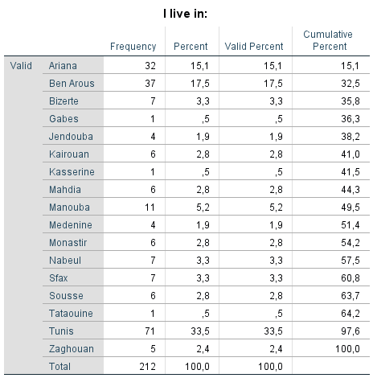

The respondents are living in 17 different governorates. 33.5% of them live in Tunis followed by 17.5% in Ben Arous, and 15.1% in Ariana. The remaining governorates were represented by smaller percentages.

=> To sum up our profiling, we noticed that the majority of the respondents were females (69.43%), 94.4% among them are younger than 38 years old, 88.7% of respondents’ income do not exceed 1500TND, and most of them live in “Grand Tunis”

* demand

Covid-19 effect on demand:

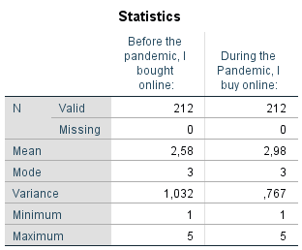

Comparing the two descriptive tables above, we witnessed:

* The variance of the demand before the pandemic outbreak was greater than 1 (1.032) which is considered a relatively high variance meaning the respondents’ frequency of online purchasing before the pandemic is quite spread out from the mean. On the other hand, the variance of the demand during the Covid-19 dropped to 0.767 < 1 which considered relatively low.
* The average frequency of the online purchase before the pandemic is 2.58 between “rarely and sometimes”. During the pandemic, the frequency slightly increased to 2.98 closer to “sometimes”. The average online purchase frequency increased by 15% during the pandemic

=> We conclude that the pandemic increased the frequency of the online purchase of our respondents.

* Satisfaction

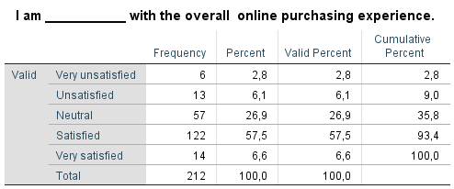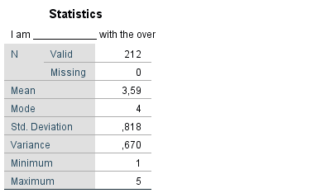

57.5% of respondents reported that they were satisfied with the overall online purchasing experience. The average responses scored 3.59 which is between “neutral” (3) and closer to “satisfied” (4).

We conclude that the majority of respondents found the overall online purchase experience quite satisfactory

* Payment

Payment methods used

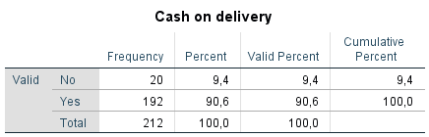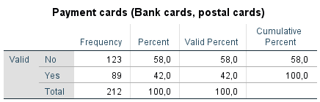

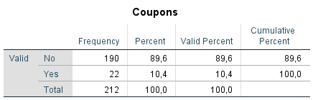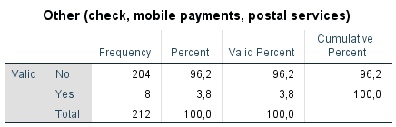

90.6% of our respondents said that they use the cash on delivery option. On the other hand, only 42% of respondents use payment cards to purchase online. This may be explained by the fear of e – payment among Tunisian citizens.

As for the coupons they were used by 10.4% of our respondents only and 3.8% reported that they were using other options for payment such as check, mobile payments, or postal services.

The security of payment methods:

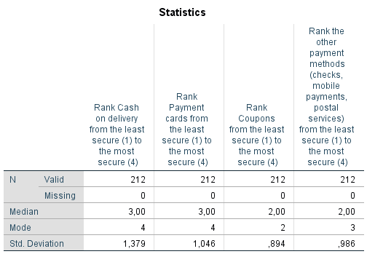

The most frequent answer from respondents concerning their perception of the security of cash on delivery and payment cards was ranking them as the most secure payment method. More than half of our respondents at least ranked them the second most secure method. As for coupons and other payment methods, half of the respondents ranked them below the second least unsecure while the most frequent respondent ranking for coupons was the second least secure and for others was the second most secure payment method.

* Product categories

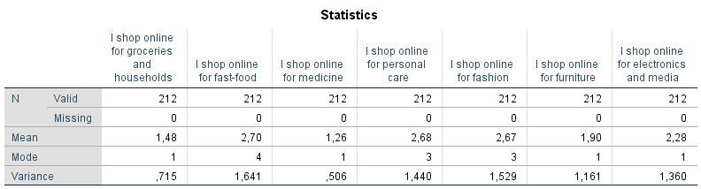

On average, respondents never bought groceries, households, and medicine online, they rarely shop for furniture, electronics, and media. Sometimes, they shop for fashion, personal care, and fast-food.

To conclude, our respondents’ frequency of online purchasing is moderate and the most products they shop for are mainly fast-food personal care or fashion.

* Continuity of behavior

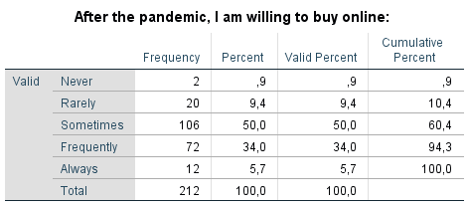

On average, respondents are willing to buy online sometimes after the pandemic. The most frequent answer is also sometimes and 50% of our respondents reported that they are willing to shop online at least “sometimes” after the end of Covid-19.

* Internet access

50.91% of our respondents use their mobile phones for online shopping, 39.62% use their computers, and only 0.47% use their tablets.

* Customer perception of local businesses capabilities

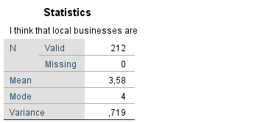

On average, our respondents agree that local businesses are succeeding to shift online. More than 50% among them either “agreed” or “totally agreed” and the most frequent answer was “I agree”. The variance is about 0.719 <1 so it is considered low which means the responses are so close to the mean.

* SODs

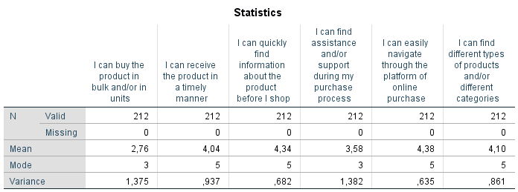

According to our respondents, Bulk breaking had a mean of 2.76> 2.5 which is considered “important”, and more than a half of our respondents perceived the bulk breaking as “important”, “fairly important” or “extremely important”. Delivery, on the other hand, was perceived as “fairly important” and the most frequent answer was  “extremely important”. As for the information provision, the average response was “fairly important” yet more than half of the respondents considered it “extremely important”. The customer support was perceived as “fairly important”, but the most frequent answer was “important”. The spatial convenience scored the highest mean, and more than half of the respondents perceived it as “extremely important”, It was actually the most frequent answer. Finally, the assortment and variety were considered “fairly important” on average and the most frequent answer was “extremely important”.

To sum up, except for bulk breaking, which was considered important, all other SODs were perceived fairly important on average.

**B- Factor analysis for the SODs**

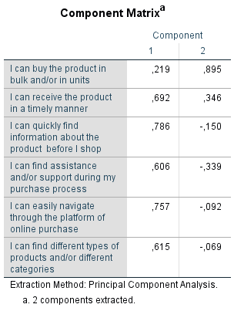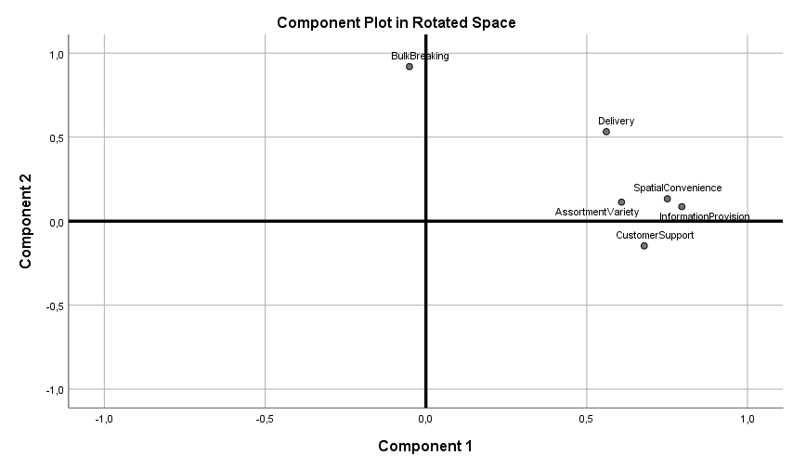

There are 2 factors with eigenvalues higher than 1. The first factor has an eigenvalue of 2.464 and it represents 41.061% of the total variance. On the other hand, the second factor has an eigenvalue of 1.070 and the second factor represents 17.841% of the total variance. Based on the factor analysis, the first factor is composed of the first item which represents the product quantity, and the second factor is composed of the remaining items which represents the quality of the product purchased and the service provided.

**2- Main results**

**A-Crosstabs analysis**

* Frequency of demand during the pandemic based on age.

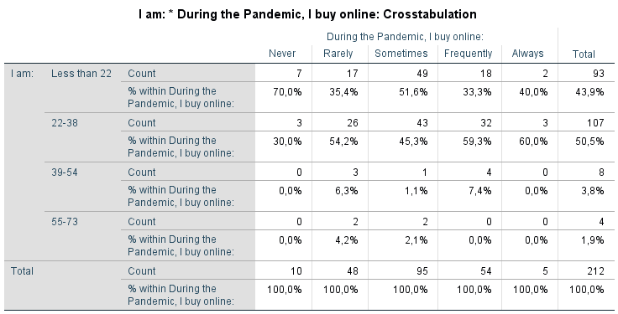

* 70% of the respondents who never bought online during the pandemic aged less than 22 (Gen-Z).
* 54.2% of the respondents who shop rarely online during the covid-19 outbreak are millennials.
* 51.6% of the respondents who shop sometimes online during the pandemic are Gen-Z
* 59.3% and 60% of the respondents who respectively buy frequently and always are millennials.
* The market for online purchasing is mainly dominated (respondents who buy frequently and always) by the millennials.
* Frequency of demand based on the status

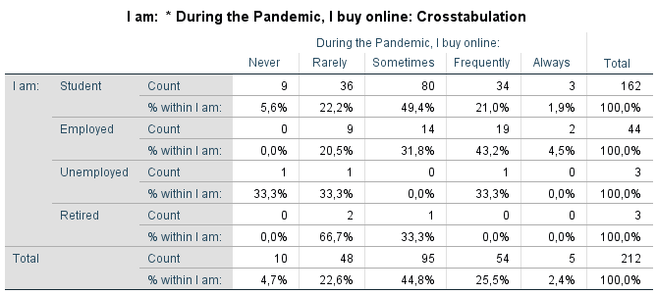

* 49.4% of students shop sometimes online during the pandemic.
* 43.2% of the employed buy online frequently during the sanitary outbreak.
* 66.6% of the unemployed respondents either never shop online, or they rarely do during the pandemic outbreak.
* 66.7% of the retired respondents rarely buy online.
* Potentially, students and employed are the most respondents who shop with good and consistent frequency.

**B - Bivariate correlation:**

Demand and satisfaction correlation:

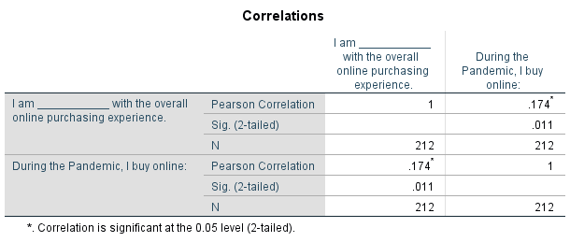

The correlation between the frequency of online purchasing during the pandemic and the respondents’ satisfaction is significant (0.011<0.05). The Pearson correlation coefficient suggests that there is a weak positive linear relationship between the two variables: the more they are satisfied with the online purchasing, the more they buy online during the pandemic, but it remains a weak effect.

Demand and continuity of behavior correlation:

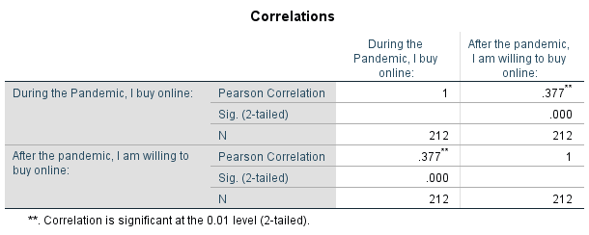

The Significance of this correlation is so below 0.05. Therefore, it is a significant correlation. On the other hand, the Pearson correlation is moderately important, and it is a positive linear correlation. Thus, we will run the regression analysis afterward to determine the exact coefficient.

Correlation between customer satisfaction and the perception of local businesses:

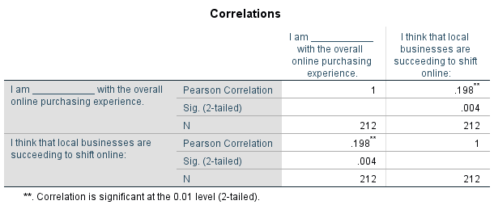

Our correlation is significant (0.004<0.05), and we witnessed a positive weak linear correlation between the satisfaction of customers and their perception of the readiness of local businesses. However, the small Pearson correlation of 0.198 is not motivating enough to run a regression analysis.

Correlation between customer satisfaction and continuity of behavior:

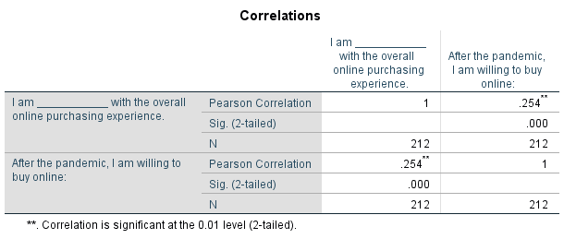

Our correlation is significant and the Pearson correlation 0.254 even though it is a weak positive correlation, however, because we are studying human behavior, we will do a regression analysis to further quantify this effect.

**C- Regression:**

Simple regression of demand and continuity of behavior: 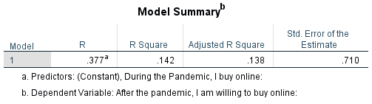

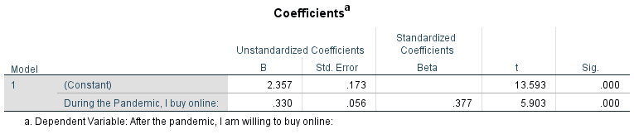 **Hypothesis tested:**

H0: $β$ = 0 (there is no dependency relationship between the demand during the pandemic and the continuity of online purchase after COVID-19)

H1: $β$ ≠ 0 (there is a dependency relationship between the demand during the pandemic and the continuity of online purchase after COVID-19).

**Interpretation:**

Our significance equals 0.00< 0.05. Therefore, we reject H0. Since our R square is 14.2%, we conclude that there is a somewhat strong correlation between the demand during the pandemic and the continuity of online purchases after COVID-19. More precisely, if the demand frequency during the pandemic increases by one unit, the continuity of the behavior after the pandemic will increase by 33%

Simple regression of customer satisfaction and continuity of behavior:

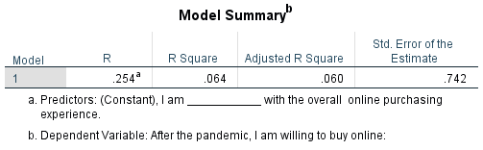

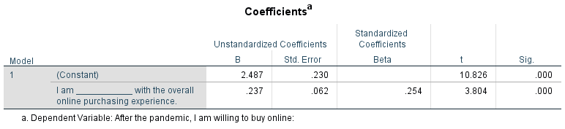

**Hypothesis tested:**

H0: $β$ = 0 (there is no dependency relationship continuity of behavior and the overall satisfaction of the respondents)

H1: $β$ ≠ 0 (there is a dependency relationship between continuity of behavior and the overall satisfaction of the respondents)

**Interpretation:**

Our significance equals 0.00 < 0.05. Therefore, we reject H0. Since our R square is 6.4%, we conclude that there is a weak correlation between continuity of behavior and the overall satisfaction of the respondents. If the satisfaction increased by one unit, the willingness to shop online after the pandemic is going to increase by 23.7%

**D- Multiple regression** 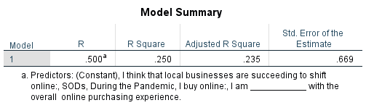

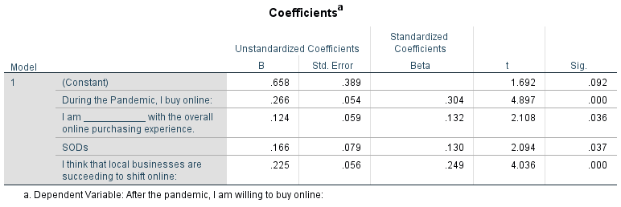

**Hypothesis:**

H0: $β$ 1= $β$ 2= $β$ 3= $β$ 4=0 (There will be no significant prediction for the continuity of behavior by the overall satisfaction of respondents, their perception of the importance of SODs, the perception of the readiness of local businesses and the frequency of demand during Covid-19 outbreak).

**Interpretation:**

We witness that all the independent variables’ significance was lower than 0.05. Therefore, we reject H0. Besides, the R squared equals 25% which is considered quite important especially that we are studying human behavior. We conclude that the continuity of the online purchasing behavior of respondents can be explained by the overall satisfaction of respondents, their perception of the importance of SODs, the perception of the readiness of local businesses and the frequency of demand during the Covid-19 outbreak, and further predicted as follows:

C= 0.658+ 0.266*V1+0.225*V2+0.124*V3+0.166*V4

with:

C= Continuity of behavior after Covid-19

V1= The online purchase demand frequency during the pandemic outbreak

V2= The perception of the readiness of local businesses by respondents.

V3= The overall satisfaction of respondents towards the online purchasing experience.

V4= The perception of the importance of SODs

E- Cluster analysis:

Classification of respondents based on overall Satisfaction and readiness of local businesses:

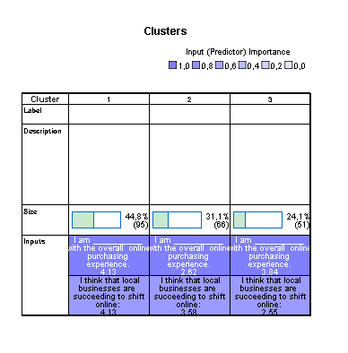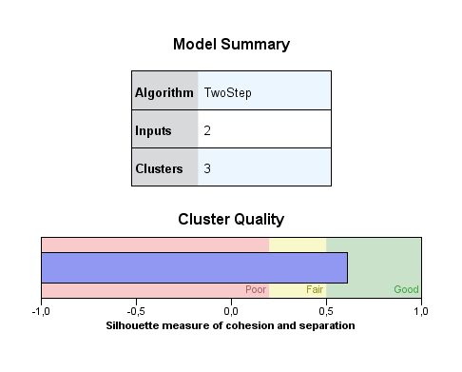

By running a two-step clustering analysis between the perception of the readiness of local businesses and the overall satisfaction of our respondents. We found a good quality measure of cohesion and separation that classified our respondents into three groups:

* **Respondents who are satisfied with the overall online purchasing experience and they think that the local businesses succeeded in the online shift:** This category represents 44.8% of our respondents with a mean of 4.13 for both variables which means they agree that businesses are ready for the online shift and they are satisfied with the overall purchasing experience.
* **Respondents who are unsatisfied with the overall online experience, yet they think that local businesses are capable of the online shift:** This category represents 31.1% of our respondents with a mean of 2.62 for the overall satisfaction and when digging into the cells distribution, we witnessed that the satisfaction varied from “very unsatisfied” to “neutral” yet their perception towards the readiness of local businesses have a mean of 3.58 which means they agree that local businesses are capable of the online shift. Therefore, there is definitely another factor affecting the satisfaction of the respondents other than the capabilities of businesses.
* **Respondents who are satisfied with the overall online purchasing experience but disagree with the readiness of local businesses in the online shift:** This category represents 24.1% of our respondents whom their satisfaction was not affected by the perceived failure of the local businesses to shift online.

Classification of respondents based on their overall satisfaction and the continuity of online purchasing after the pandemic: 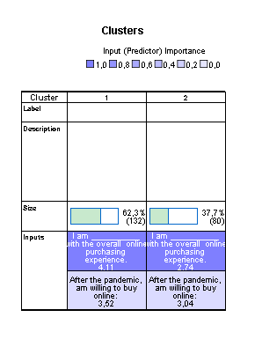

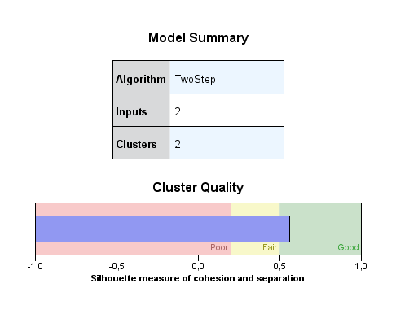

By running the two-step cluster analysis, we distinguished between two groups of respondents: 62.3% of respondents are **satisfied** with the overall online purchasing experience and are willing to **buy online frequently** even after the end of the pandemic and 37.7% of **neutral** towards their satisfaction of the online purchasing experience yet they will **sometimes buy online** after the pandemic outbreak.

# **Recommendations**

* **Increasing the quality of the services provided** is highly appreciated by customers and thus highly recommended.
* Phones are the most used devices for online shopping. Working on **enhancing the user experience for online platforms** and making them adapted to mobile use is recommended. (the ease of navigation of online platforms *aka spatial convenience* is the most important service output demand according to our respondents. In other words, it’s what they value the most in an online shopping experience)
* **Building Customer loyalty programs** for those who are satisfied with the online shopping experience is recommended since there is an important number of those customers who are willing to buy again after the pandemic. (This will increase profits)
* **Attracting those who made previous purchases** and increasing their satisfaction level is recommended since an important number of them are willing to buy again after the pandemic.
* **Starting an online shop for the following product categories**: Fast-food, personal care, and fashion
* Seeing that currently there is an online demand and an important frequency of purchasing of these types of products.
* **Encouraging business owners to make the decision of online shift** in this specific timing as customers’ perception of businesses’ readiness is relatively high depending on the results of the second cluster.

# **Conclusion & limitations**

**Limitations:**

* We could not explain the effect of Covid-19 on online shopping experience using the age variable since **the sample is not representative of all age classes**.
* We could not explain the effect of Covid-19 on online shopping experience using status/Income variables since **the sample is not representative of all social classes**.
* Wecould not **fully explain what drives the satisfaction** of the customers. There are other factors that we did not identify. This is a point to be considered for further research.
* Some variable types were not selected accurately from the beginning and the type chosen was not very beneficial for the objectives of the research such as the ordinal type in the perception of the security of payment methods which could have been better if an interval scale was applied.

**Conclusion**

Through our study, we validated the assumption of the COVID-19 impact on the online purchasing behavior in Tunisia. A considerable portion of the studied sample confirmed their willingness to purchase online even after the pandemic will be over. In addition, businesses shifting to the online channel seemed successful and promising for the customers. However, capitalizing on augmenting the services associated with the purchasing experience is a must, in conjunction with capitalizing on the customer’s experience. The fast-food and personal care & fashion industries ranked first in terms of the most consumed product categories by our respondents which highlights a big opportunity for growth for current businesses in these industries and might attract new ones. Nonetheless, our study’s findings could be more accurate and more insightful had we worked on larger sample size.

1. **References**

(n.d.). From Glopal for merchants:

https://merchants.glopal.com/en-gb/sell-online/tunisia#:~:text=The%20top%20ecommerce%20sites%20n,and%20tunisie%2Dannonce.com.

(2018). From http://www.tunisia-survey.com/barometre-ecommerce/barometre-ecommerce-resultat/

Data reportal. (2020). From https://datareportal.com/reports/digital-2020-global-digital-overview

MarketeuZ. (2008). From https://www.marketeuz.com/article-pourquoi_le_tunisien_n_achete_pas_en_ligne_-32.htm

MDWEB. (2018). From http://www.tunisia-survey.com/barometre-ecommerce/barometre-ecommerce-resultat/